Complete Project Title

by
Student’s Name (first, then last name)

Final Year project submitted in partial fulfilment of the requirements for the Degree of
Bachelor of Science in Computer Science

Department of Computer Science
School of Sciences
University of Nicosia
May, 2011 (month, year)
Thesis Title
By
Student Name

This Final Year Project has been accepted in partial fulfilment of the requirements for the Degree of
Bachelor of Science in Computer Science

Project Advisor:

/ /
(Name) (Signature) (Date)

Examiner:

/ /
(Name) (Signature) (Date)

Examiner:

/ /
(Name) (Signature) (Date)

Department of Computer Science
School of Sciences
University of Nicosia
Abstract
The abstract is a brief summary of your project (up to 500 words). It should include the purpose of the project and its objectives, a brief description of the approach or methodology and a few sentences about the outcome of the project (e.g. conclusions). The purpose of the abstract is to provide an overview so that by reading only the abstract the reader can tell what the project is about and decide whether to read the rest of your report. A good idea is to write the abstract after the rest of the report is completed. Here is an example abstract from a real project:
The purpose of this project is to develop a distributed system for data processing based on off-the-shelf computer hardware. The system developed consisted of sixteen Pentium computers connected with a 100Mbps Ethernet all running under the Linux operating system. Sharing of resources was achieved using the Parallel Virtual Machine (PVM), which was automatically activated on all machines. A software Application Programming Interface (API) was built using the C++ language on top of PVM to provide applications with a simple, flexible interface and also to support load balancing, fault tolerance and error recovery. The system was tested by developing two simple applications and four standard benchmarks. Results indicated an almost linear speedup for computationally intensive applications, but the system did not perform as well as expected for network intensive applications. One of the drawbacks of the system is that performance is reduced substantially when more than one application is executing under PVM, in which case load balancing performed poorly.

Acknowledgements
In the acknowledgements you normally thank people who helped you somehow in completing your project. Here are some examples.
I would like to thank my parents for their encouragement and financial support during my studies. Also my project advisor for his critical questions, which forced me to read more, think critically and write with better clarity and for teaching me that we learn by doing. Special thanks also go to my friend John Smith, who read my project report and helped me with the grammar and style. I would also like to express my gratitude to my Manager, Ms Mary Jones for agreeing to give me time release to complete this project and for her understanding when I came late for work. Finally I would like to acknowledge the Science Foundation for the scholarship during my final year, which made it easier for me to complete this project.
Table of Contents
Chapter 1 Introduction 1
1.1 Headings 1
1.1.1 Subheadings 1
1.2 Page Formatting 2
1.2.1 Margins 2
1.3 Tables and Figures 2
1.4 Equations 4
1.5 Program fragments 4
Chapter 2 Language, grammar and style 6
2.1 General style guide 6
2.2 Special issues 7
References 8
Appendices 10

List of Tables
The list of tables is included only if there are tables in your project report. These are listed here along with their caption (description) and the page number where they appear (see example).
Page
Table 1 Comparison of PVM and MPI 7
Table 2 Results with Load Balancing Enabled 12
List of Illustrations
Like the list of tables, but shows the figures. These are listed here along with their caption (description) and the page number where they appear (see example).
Page
Figure 1 A Network of Workstations 5
Figure 2 Performance Improvement with added nodes 12

Introduction

Headings
This is an example of how the project report should be formatted. Note that the pages up until the first chapter are numbered with Roman numerals (i), (ii), etc., whereas from now on Arabic numerals are used for the page numbering, starting at 1. Page numbers appear on the top right corner of each page. The preferred size for normal text is 12 pts. In any case, the normal text size you should use should be no more than 14 pts in size and no less than 10 pts. Normal text should be double spaced. The font you should use for your report should be either Times Roman, or Arial (Sans Serif). The main body of the report should be at least 50 pages long.
Paragraphs should be clearly marked. Chapters should be numbered consecutively and should start on a separate page. Headings should be in bold and must use a font larger than normal text, but smaller than chapter headings. Headings should be numbered sequentially using the decimal notation prefixed with the chapter number.

Subheadings
Subheadings should have font size not smaller than the normal text and no greater than the font for headings. The decimal format should also be followed here.

Sub-subheadings
Other sub-divisions may be used. The general rule is that they should have a font size no greater than the heading before it, or smaller than the size for normal font.

Page Formatting
Pages should be formatted in a consistent way. The project must be printed on white A4 size paper (210 mm  296.9 mm). Printing should use a quality printer, e.g. a laser printer with resolution of at least 300 dpi.

Margins
The top and bottom margins should be 20 mm each. The left margin should be 40 mm and the right margin should be 20 mm. The printable area should be 150 mm  256.9 mm.

Tables and Figures
Tables should use text, which is not greatly different in size than the normal text font. Tables should be included in the text close to the location of their first reference. Each table must have a caption on the top, giving the table number and a description. The table number may follow a simple numbering format, e.g. Table 1, Table 2, etc. or a decimal numbering format using the chapter number, e.g. Table 1.1, Table 3.2, etc.
A table is referenced in the text using its number. See Table 1 for an example.
Table 1: Execution times for different configurations
Execution Time (sec) | Configuration  (number of processors)
Application Type | 1 | 2 | 4 | 8 | 16 | 32
Benchmark 1232A | 13.25 | 7.82 | 4.20 | 3.55 | 2.89 | 3.20
Benchmark 2241 | 8.23 | 7.34 | 7.02 | 7.02 | 7.03 | 7.01
Image Filtering | 24.45 | 14.30 | 9.92 | 6.77 | 4.43 | 4.21
Database Search | 10.23 | 6.67 | 6.05 | 5.92 | 6.50 | 7.89
Figures should be included in the text close to the location of their first reference. Each figure must have a caption at the bottom, giving the figure number and a description. The figure number may follow a simple numbering format, e.g. Fig. 1, Fig. 2, etc. or a decimal numbering format using the chapter number, e.g. Fig. 1.2, Fig. 4.5, etc. Figures should be clear. Any images must have a resolution of at least 300 dpi. A figure is referenced in the text using its number. See Fig. 1 below.
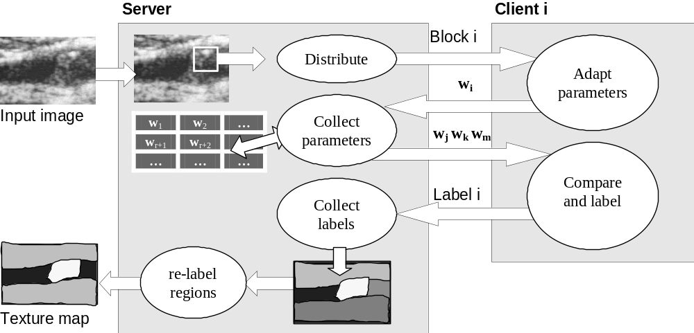
Figure 1: Distributed client-server image processing application
In case colour is required, the figure may be included on a separate page (properly numbered). Photographs and other materials should be firmly fixed onto the page, or scanned and printed on normal paper, like in Fig. 2.
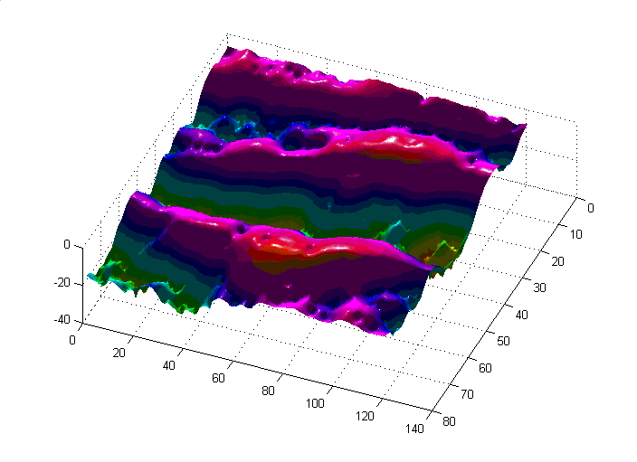
Figure 2: Reconstructed height from single image

Equations
Equations should be properly formatted. There are two types of equations, in-line and stand-alone. In-line equations like this, 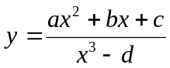, appear along with the text inside a paragraph. These equations do not have a number and therefore cannot be referenced. Usually in-line equations are simple. Stand-alone equations appear on a separate paragraph/line and are numbered sequentially with a number in brackets close to the right margin next to the equation:
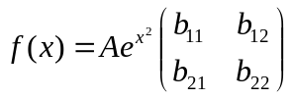 (1)
Numbering can follow either a simple sequential format, or can use the decimal notation, to number each equation for each chapter, (1.1), (1.2) etc. To refer to an equation us the corresponding number, prefixed with the word Eq. For example to refer to the above equation, write ‘see Eq. (1)’.

Program fragments
In Computer Science projects it is often required to provide program listings and describe their function or purpose. Program listings should appear in a different style that normal text, Usually a proportional font, such as Courier is more appropriate; indentation and background may also be used to emphasize that it is a program listing. Lines should be numbered for easy reference. You may place a program listing in a figure if you need to refer to it from different sections or chapters, or provide it exactly at the location where it will be described. An example listing is given on the following page. Note that the indentation is different from normal text and that a frame has been placed around the code to highlight it. You may also use shading to emphasize code, but remember that shading may be distorted during photocopying and it may make your text difficult to read.
- char token_buffer[BUFSIZE+1];
- static int buffer_idx = 0;

- /* appends c to the end of token_biffer[] */
- void buffer_char(char c)
- {
- if (buffer_idx<BUFSIZE) {
- token_buffer[buffer_idx++] = tolower(c);
- token_buffer[buffer_idx] = '\0';
- }
- }
Remember that if a long program listing is included in a chapter, reading the corresponding chapter will be difficult, so ask yourself whether including the whole listing is really important in the chapter. Often, a small fragment is sufficient to explain how your program operates. The complete program may be listed in the Appendix, or provided on a CD-ROM or other medium and the reader may be directed to look there.

Language, grammar and style

General style guide
The style used in the report should be that of formal technical writing. First person references, such as ‘I designed the database using the guidelines…’ or ‘we tested the system by applying the … benchmarks’ should be avoided. Instead, use passive voice statements, such as ‘the database was designed using the guidelines…’ or ‘the system was tested by applying the … benchmarks’.
Generalizations should be avoided. Expressions such as the following do not mean much and do not show what was actually done (if anything).
Various programming languages were considered and then we chose Java because it is the best.
Explain what was actually done, for instance the following statement is much more precise and meaningful:
The programming languages considered for this project were C++ and Java. Because it was necessary to develop a system with a portable Graphical User Interface Java was finally chosen.
Another item to pay attention to while writing the report is to avoid exaggerated claims about the results of the project and also to document the work actually done, not the work that should have been done (and was not done). It is quite common for a student to follow a different, often incorrect, way of software development (e.g. coding without a design, a database that was not normalized, etc.) and then in an attempt to show that a system design methodology was followed to have several chapters on design added afterwards in the project. Frequently these do not correspond with the actual work done, or, even worse, the actual work is not described at all, resulting in poor project reports and often project failure.

Special issues
References should be used throughout the project. The general rule is that unless a claim was proved by testing during the project (and hence documented), it must be supported by referencing a book or article that described and performed the tests and has drawn the same conclusion. For instance, writing the following
The DBMS used for this project was Oracle because it supports larger databases than MS Access.
would make the reader expect to see in a later chapter some test to prove this and if there is no such test described, the question of how this conclusion was drawn would be raised (most certainly by an examiner during the presentation of the project). If instead the above statement was based on an article or a book (by an author named Brown, listed in the references as number [12]), then the above statement could be written as follows, leaving no questions, since the responsibility of the test lies with the author of the reference where the claim was made.
The DBMS used for this project was Oracle because it supports larger databases than MS Access, as proven by Brown[12].

References
References and bibliography must be listed following a standard format. The most commonly referenced documents are books, Journal articles, Conference proceedings publications and URL’s. References must include a number in square brackets for referring to inside the body of the report.
Books listed shall include the following information in the order shown:
- First name or initials and last name of author or authors, or name of organization
- Title of book (in italics)
- Edition number (if applicable)
- Place of publication (city)
- Name of publisher
- Year of publication
- ISBN
- First and last page of reference
Example:
  - Silberschatz, P.B. Galvin, and G Gagne, Operating Systems Concepts,6th ed., NY, John Wiley & Sons, 2003, ISBN 0-471-26272-2, pp. 332–360.
Journal articles listed shall include the following information in the order shown:
- First name or initials and last name of author or authors, or name of organization
- Title of article in quotation marks
- Title of periodical in full, set in italics
- Volume, number, and, if available, part
- First and last pages of article
- Date of issue
Example:
  - I.E. Sutherland, R.F. Sproull, and R.A. Schumaker, "A Characterization of 10 Hidden-Surface Algorithms," ACM Computing Surveys, vol. 6, no. 1, Mar. 1974, pp. 1–55.
Conference proceedings articles listed shall include the following information in the order shown:
- Last name of author or authors and first name or initials, or name of organization
- Title of article in quotation marks
- Conference title, set in italics, including the conference initialism in parentheses
- Volume, if available
- Name of publisher
- Year of publication
- First and last pages of article
Example:
  - S.A. Mylonas, "A Novel Approach to Detect Shape From Shading," Proc. 2nd Int'l Conf. on Medical Signal and Info. Processing. (MEDSIP 2004), IEE Press, 2004, pp. 272–278.
URLs listed shall include the following information in the order shown:
- Last name of author or authors and first name or initials, or name of organization, where applicable
- Title of article, or page, in quotation marks
- Date or year of publication, whichever applicable
- The complete fully qualified URL of the web resource. If it does not fit on a single line, the URL should be split ether at a / or a dot (.).
Example:
  - R. Bartle, "Early MUD History," Nov. 1990; http://www.ludd.luth.se/mud/aber/
mud-history.html.
  - IEEE Computer Society, "Style Guide," Jan. 2004; http://www.computer.org/
author/style/refer.htm
References may be listed either in the order of first appearance in the body of the report, or in alphabetical order of first author’s last name. As an example consider the reference in the body of the text in section 2.2.

Appendices
Appendices normally contain secondary, or supporting material, whose inclusion in the main body of the report would either make the project difficult to read, or is not very important. There may be more than one appendix, numbered with capital letters, e.g. Appendix A, Appendix B, etc.
Example of material that is included in an appendix:
- A user’s manual for a software application or system
- An installation manual for a software application or system
- Listings of source code for software written, if not too long, otherwise it can be provided on a diskette or CD-ROM. If on CD-ROM, the appendix should still be present in the form of a single page with a title and a brief note on where to find the material.
- Secondary materials, such as example screen shots of the program in operation, test cases or procedures, questionnaires, additional results.
University of Nicosia, Department of Computer Science, School of Sciences and Engineering
Prepared by:
Socrates A Mylonas (January 2005)
Revisions:
Socrates A Mylonas (February 2005)
Vasso Stylianou (December 2007)

Footnotes can be used. They can be numbered, or use special symbols, such as † or ‡, etc.

